**Exercise 3: Implementing Logging with Spring AOP**

**Scenario:**

The library management application requires logging capabilities to track method execution times.

**Steps:**

1. **Add Spring AOP Dependency:**
   * Update **pom.xml** to include Spring AOP dependency.
2. **Create an Aspect for Logging:**
   * Create a package **com.library.aspect** and add a class **LoggingAspect** with a method to log execution times.
3. **Enable AspectJ Support:**
   * Update **applicationContext.xml** to enable **AspectJ** support and register the aspect.
4. **Test the Aspect:**
   * Run the **LibraryManagementApplication** main class and observe the console for log messages indicating method execution times.

<project xmlns="http://maven.apache.org/POM/4.0.0" xmlns:xsi="http://www.w3.org/2001/XMLSchema-instance" xsi:schemaLocation="http://maven.apache.org/POM/4.0.0 https://maven.apache.org/xsd/maven-4.0.0.xsd">

<modelVersion>4.0.0</modelVersion>

<groupId>com.library</groupId>

<artifactId>LibraryManagement</artifactId>

<version>0.0.1-SNAPSHOT</version>

<dependencies>

<dependency>

<groupId>org.springframework</groupId>

<artifactId>spring-context</artifactId>

<version>5.3.36</version>

</dependency>

<dependency>

<groupId>org.springframework</groupId>

<artifactId>spring-aspects</artifactId>

<version>5.3.36</version>

</dependency>

<dependency>

<groupId>org.springframework</groupId>

<artifactId>spring-context</artifactId>

<version>5.3.32</version>

</dependency>

<dependency>

<groupId>org.springframework</groupId>

<artifactId>spring-aop</artifactId>

<version>5.3.32</version>

</dependency>

<dependency>

<groupId>org.springframework</groupId>

<artifactId>spring-webmvc</artifactId>

<version>5.3.32</version>

</dependency>

<dependency>

<groupId>org.aspectj</groupId>

<artifactId>aspectjweaver</artifactId>

<version>1.9.19</version>

</dependency>

</dependencies>

<build>

<plugins>

<plugin>

<groupId>org.apache.maven.plugins</groupId>

<artifactId>maven-compiler-plugin</artifactId>

<version>3.8.1</version>

<configuration>

<source>1.8</source>

<target>1.8</target>

</configuration>

</plugin>

</plugins>

</build>

</project>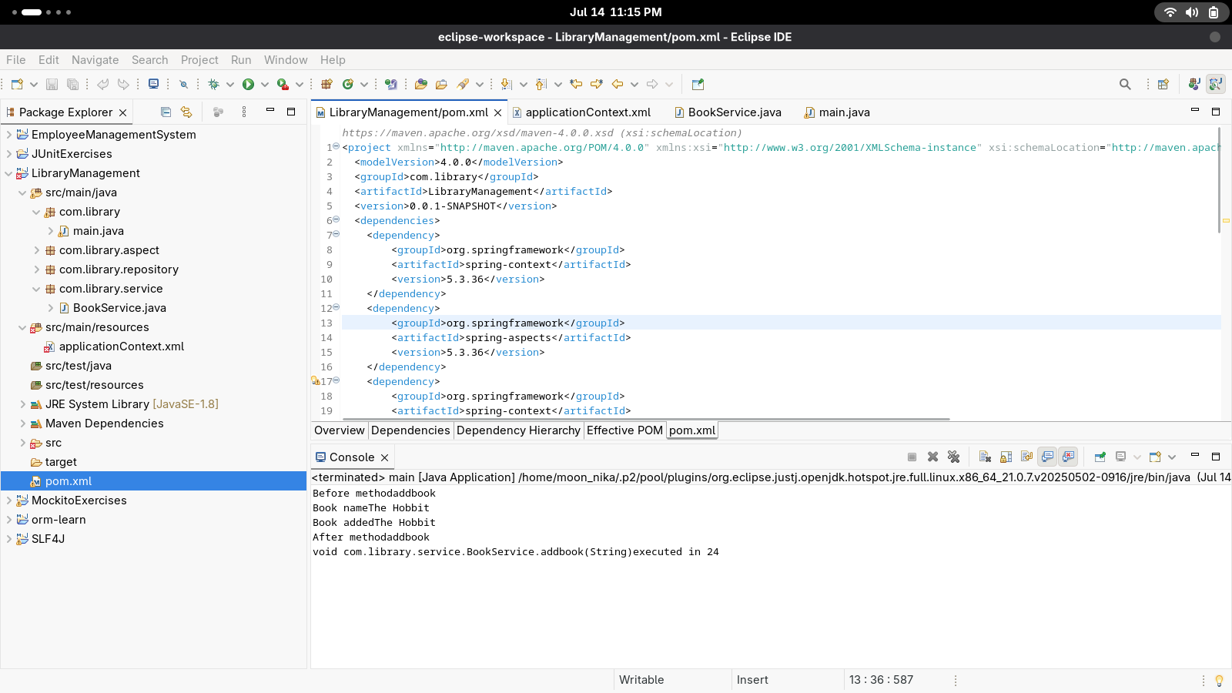

**package** com.library.aspect;

**import** org.aspectj.lang.ProceedingJoinPoint;

**import** org.aspectj.lang.annotation.*;

**import** org.springframework.stereotype.Component;

**import** org.aspectj.lang.JoinPoint;

**import** org.aspectj.lang.annotation.Aspect;

**import** org.aspectj.lang.annotation.Before;

**import** org.aspectj.lang.annotation.After;

@Aspect

@Component

**public** **class** LoggingAspect {

@Around("execution (* com.library.service.*.*(..))")

**public** Object logExecutionTime(ProceedingJoinPoint joinPoint) **throws** Throwable{

**long** start = System.*currentTimeMillis*();

Object result = joinPoint.proceed();

**long** duration = System.*currentTimeMillis*() - start;

System.***out***.println(joinPoint.getSignature() + "executed in " + duration);

**return** result;

}

@Before("execution(* com.library.service.BookService.*(..))")

**public** **void** Before(JoinPoint joinPoint) {

System.***out***.println("Before method" + joinPoint.getSignature().getName());

}

@After("execution(* com.library.service.BookService.*(..))")

**public** **void** After(JoinPoint joinPoint) {

System.***out***.println("After method" + joinPoint.getSignature().getName());

}

}

<?xml version="1.0" encoding="UTF-8"?>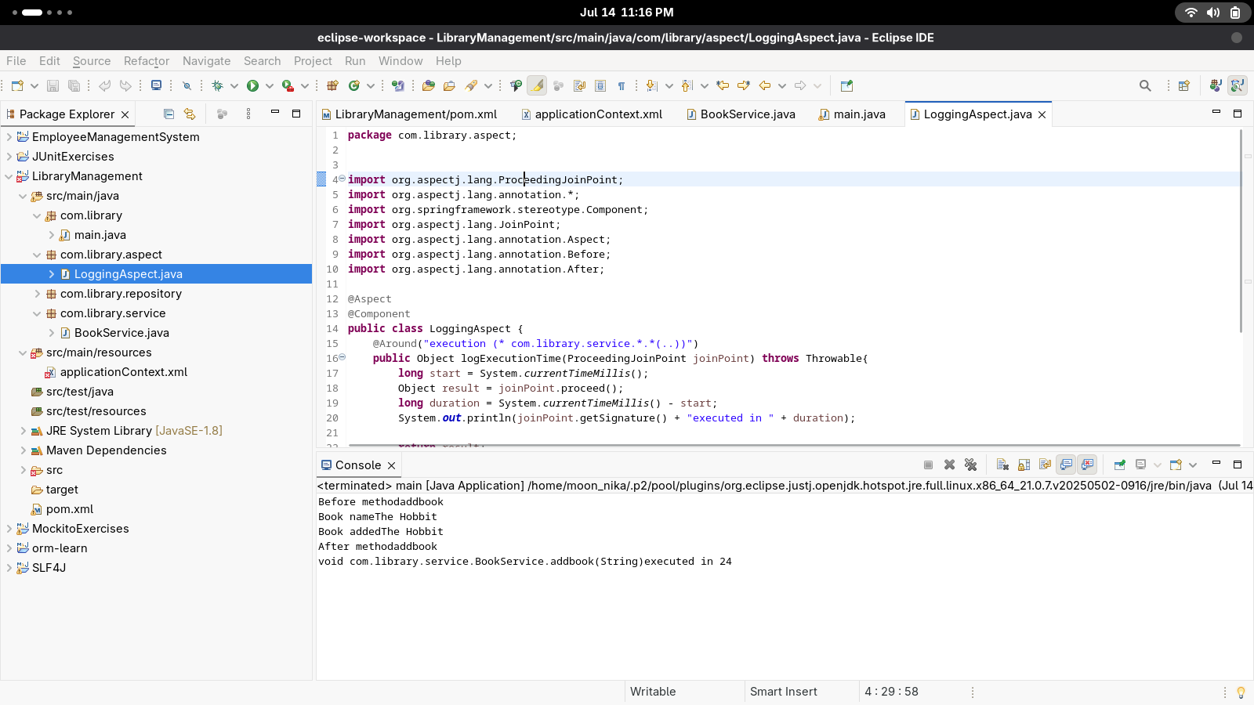

<beans xmlns="http://www.springframework.org/schema/beans"

xmlns:xsi="http://www.w3.org/2001/XMLSchema-instance"

xmlns:context="http://www.springframework.org/schema/context"

xmlns:aop="http://www.springframework.org/schema/aop"

xsi:schemaLocation="

http://www.springframework.org/schema/beans

http://www.springframework.org/schema/beans/spring-beans.xsd

http://www.springframework.org/schema/context

http://www.springframework.org/schema/context/spring-context.xsd

http://www.springframework.org/schema/aop

http://www.springframework.org/schema/aop/spring-aop.xsd">

<aop:aspectj-autoproxy/>

<context:component-scan base-package="com.library" />

<bean id="bookRepository" class="com.library.repository.BookRepository" />

<bean id="bookService" class="com.library.service.BookService">

<constructor-arg ref="bookRepository"/>

<property name="bookRepository" ref="bookRepository" />

</bean>

<bean id="loggingAspect" class="com.library.aspect.LoggingAspect" />

</beans>

